WHO Said What About Wuhan?

International investigators ignore the lab-leak theory but investigate frozen fish.
By Scott Gottlieb
Feb. 21, 2021 1:46 pm ET
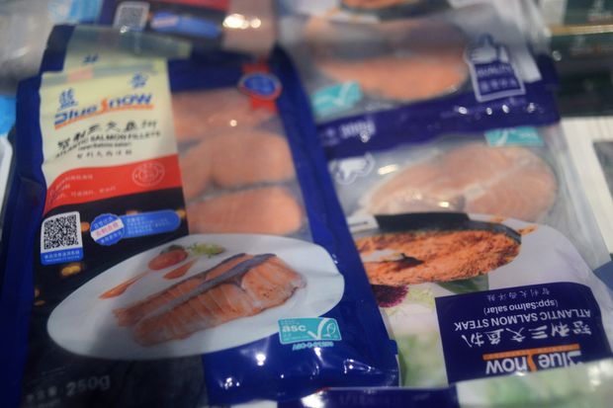 | Frozen seafood products made from imported salmon at a supermarket in Beijing, June 17, 2020.  PHOTO: TINGSHU WANG/REUTERS
Chinese policy makers have been floating an implausible theory: The novel coronavirus didn’t originate in China but was imported from Europe. That’s what a former chief epidemiologist of the Chinese Center for Disease Control and Prevention told an academic conference last fall. One theory is the virus rode into Wuhan on frozen-food packaging.
This month the World Health Organization visited China to investigate the origins of the virus. A member of the WHO delegation said it's “possible that a frozen carcass could have been shipped” to China and introduced the virus, giving some validation to the food-packaging idea. Reporting has suggested that China required the WHO to agree it would investigate the food hypothesis as a condition of entering Wuhan. By lending credence to this improbable theory, WHO is damaging trust in the important project of figuring out where the virus originated.
The most common culprit cited by Chinese officials is frozen salmon, though officials have also suggested the virus may have hitched a ride on frozen cod, pig heads or other products. In response, Beijing has suspended imports of some food products and introduced inspections and tests of frozen food, which has frequently held up imports from the U.S. and Europe.
The U.S. Food and Drug Administration weighed in last week with a forceful statement. “There is no credible evidence of food or food packaging associated with or as a likely source of viral transmission,” the Acting Commissioner Janet Woodcock said in a Covid update on Thursday.

Other scientific bodies have reached similar conclusions. The International Commission on Microbiological Specifications for Foods has stated: “Despite the billions of meals and food packages handled since the beginning of the COVID-19 pandemic, to date there has not been any evidence that food, food packaging or food handling is a source or important transmission route.” More than 100 million cases of Covid have been diagnosed world-wide and, outside China, not a single case has been traced to food or food packaging.
To its credit, the Biden administration has said it will reject the WHO findings absent independent verification. “The Chinese, at least heretofore, have not offered the requisite transparency that we need,” State Department Spokesman Ned Price said earlier this month. “We will work with our partners, and also draw on information collected and analyzed by our own intelligence community,” rather than “rush to conclusions that may be motivated by anything other than science.”
The virus most likely emerged from nature, bouncing between animals and humans before it finally broke out. It’s also possible that the virus escaped from a lab where it was being studied. Someone could have become infected while handling samples, and there’s been particular suspicion about the Wuhan Institute of Virology, a high-security research lab that was experimenting with coronaviruses. The theory of a lab leak is exaggerated by some fringe commentators, who suggest that the virus was deliberately engineered. But it’s plausible to wonder about a lab accident.
The WHO team said the lab-escape theory is so remote that it doesn’t merit any further investigation. But frozen salmon does? By giving weight to the food theory, the WHO is making itself less credible, which is a pity. The WHO provides important public-health functions, especially in low- and middle-income nations, where its assistance saves lives. Its work is essential. But the WHO risks eroding its standing and mission if it trades rigor for access and the pretense of relevancy.
Dr. Gottlieb, a physician and resident fellow at the American Enterprise Institute, was commissioner of the Food and Drug Administration, 2017-19 where he helped implement the Food Safety Modernization Act.

